Lab 14 Create Azure Databricks Cluster and Query data from a notebook

- From Azure portal, search for Databricks & click on Databricks to Create a new Databricks Cluster.
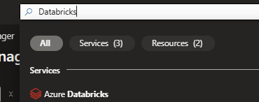

- Provide the details like resource group, Databricks workspace name, workspace tier select “Trial(Premium – 14 days free DBU), region and managed resource group.
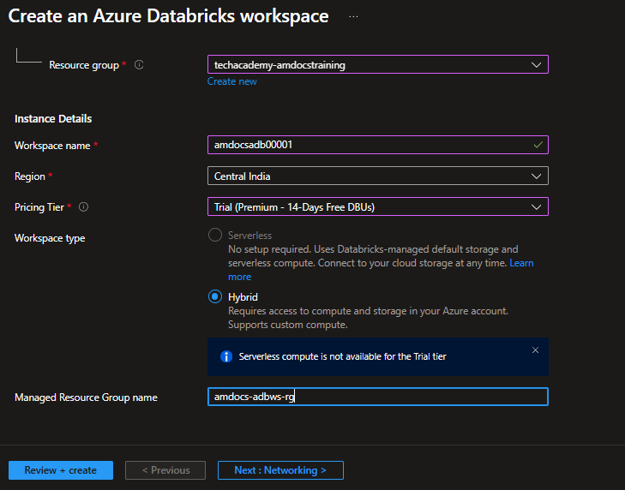
- Under “Networking” tab, provide the details of public endpoints.
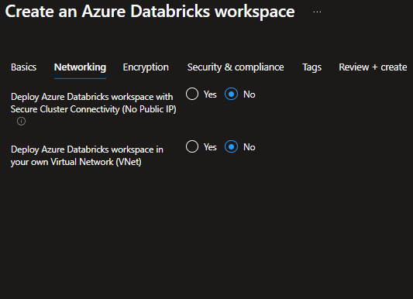

- Select the encryption and security settings as default and click on Review & Create to deploy Azure Databricks workspace.

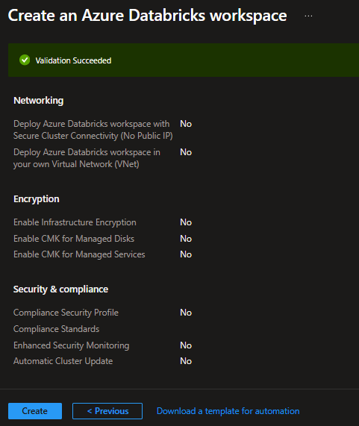

- Click on “Launch Workspace” from the Overview tab of the Databricks cluster.
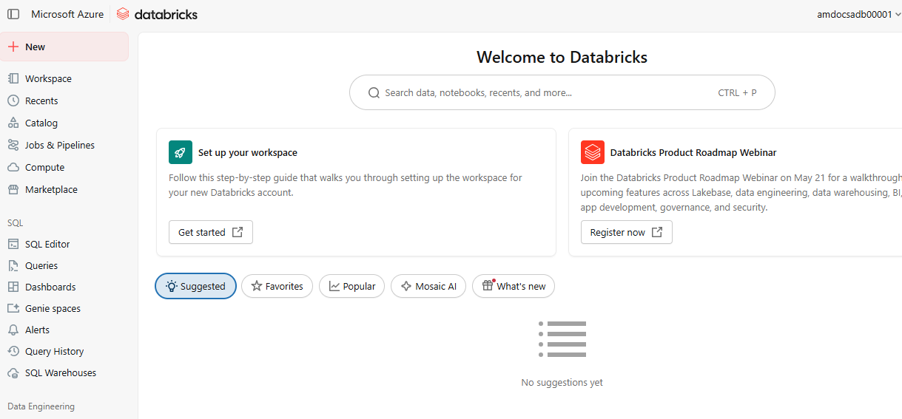

- Click on “New” and select “Notebook” from the section to create a new notebook.
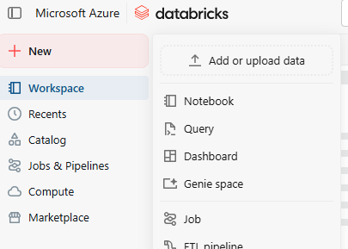

- Under Compute tab, create new to deploy a new compute cluster to run the Databricks job.
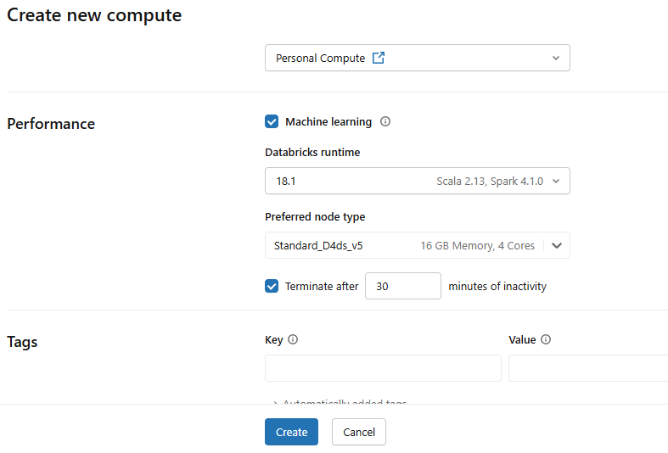

- Click on New tabs and create a new notebook. Paste the following code to retrieve the sample data. Ensure the attach the compute cluster with the job.

- SELECT * FROM samples.nyctaxi.trips
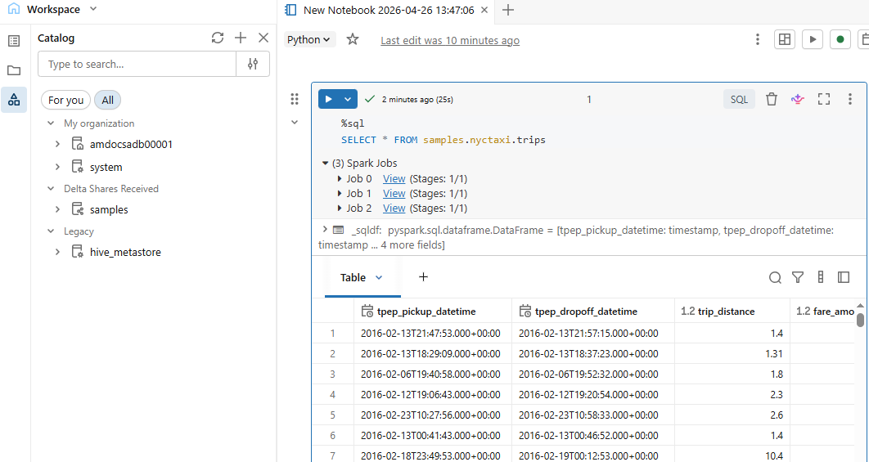

- Display the average fare amount by trip distance, grouped by the pickup zip code.
- Next to the Table tab, click + and then click Visualization.
- The visualization editor displays.
- In the Visualization Type drop-down, verify that Bar is selected.
- Select fare_amount for the X column.
- Select trip_distance for the Y column.
- Select Average as the aggregation type.
- Select pickup_zip as the Group by column.
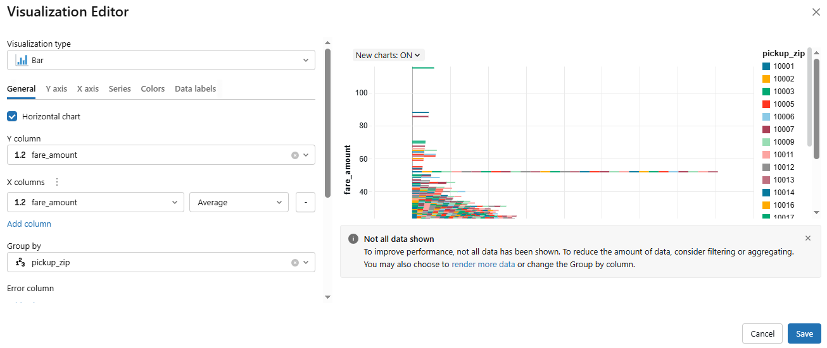

- Delete the Compute cluster and decommission the databricks workspace.
